  
FACULTY OF COMPUTING AND INFORMATION TECHNOLOGY

**BACHELOR OF SCIENCE IN SOFTWARE DEVELOPMENT**

**UNIT: BSD 3106**

**SOFTWARE COMPUTING PROJECT**

**TITLE: KCA UNIVERSITY COMMUNICATION MANAGEMENT SOFTWARE**

(Project User Manual)

**BY: MUMO SAMUEL:18/06611**

**Reg No – 18/06611**

Email: mumosamuel254@gmail.com

**SUPERVISOR: MR. PETER KIARIE**

**Presented on 18/07/2022**

Contents

Creating a user account 3

steps 3

Login 5

Create a post 5

steps 5

Editing post 7

steps 7

Deleting post. 8

steps 8

Commenting on a post 8

steps 8

Seeing your followers 9

steps 9

Using search box 10

Following a user 11

steps 11

Unfollowing a user 11

Liking and dislike 12

Change username or email 12

steps 12

To change profile picture 13

steps 13

Creating admin prompt 13

steps 13

Login as admin 14

Create group 15

Adding users to groups 16

# Creating a user account

Fig 1.0

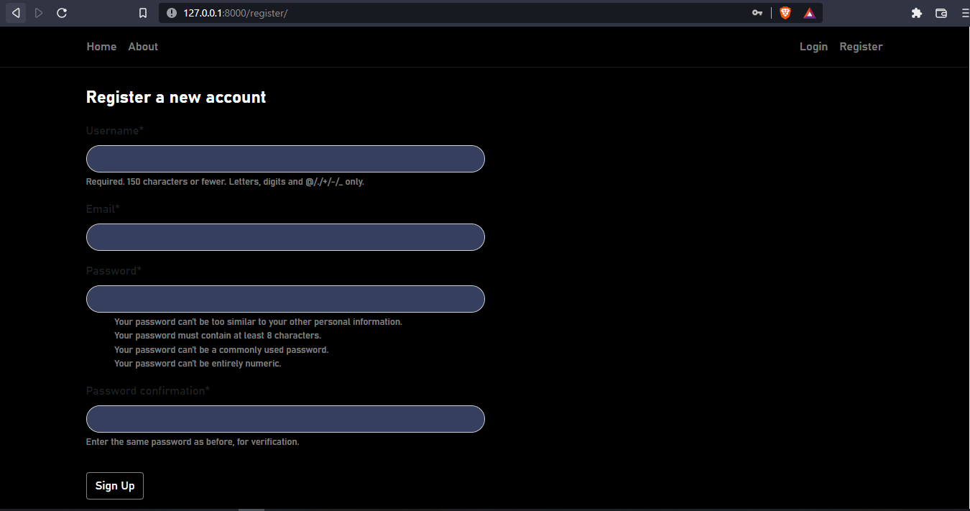

## steps

1. Select your preferred username
2. Enter a valid email
3. Input a password that meets the present standards otherwise below error will occur and account will not be created

Fig 1.1

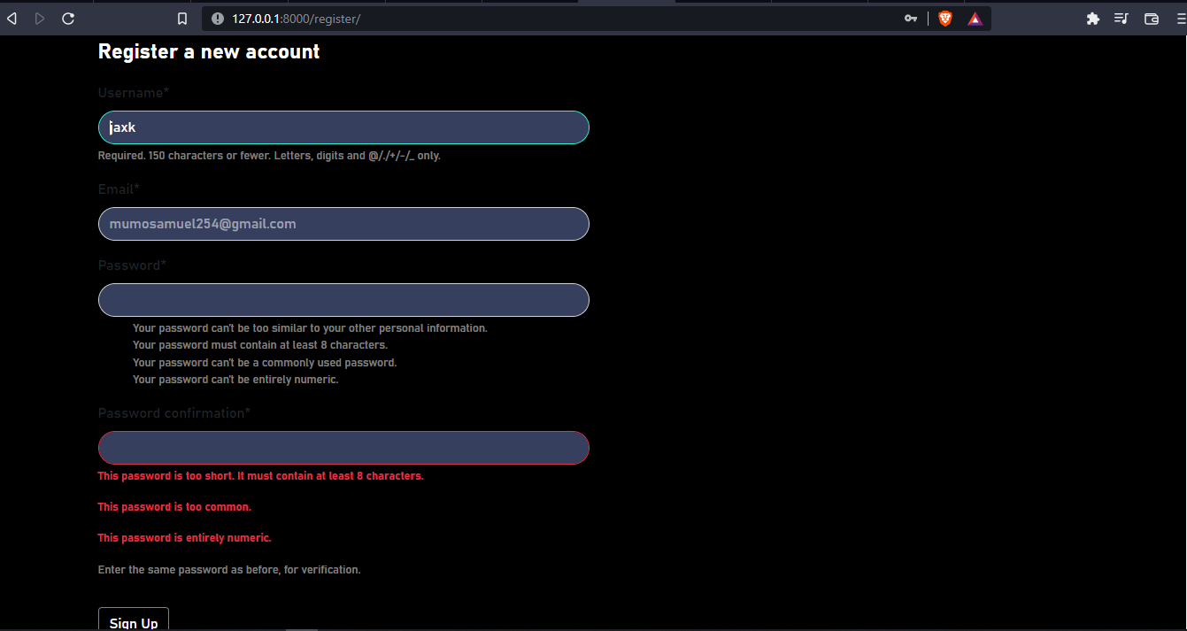

Fig 1.2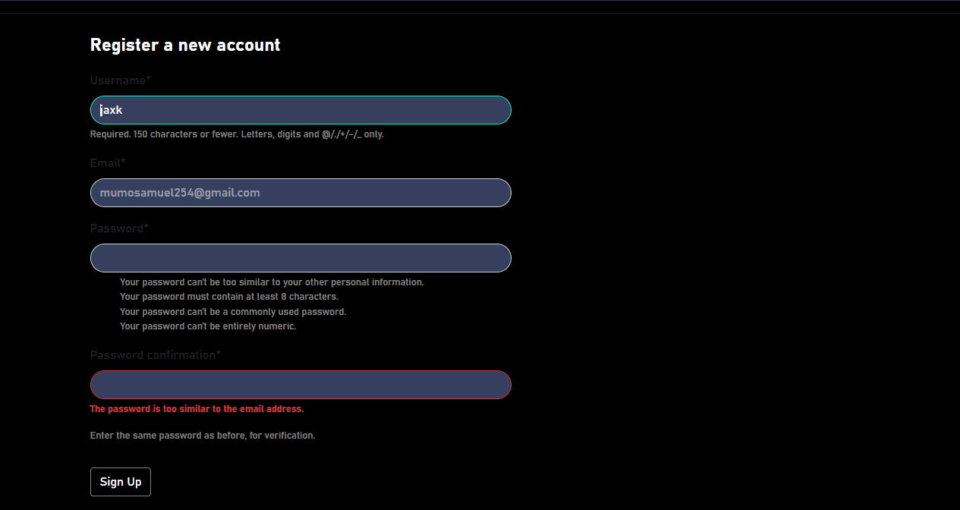

1. Success message is displayed once account is created

Fig 1.3

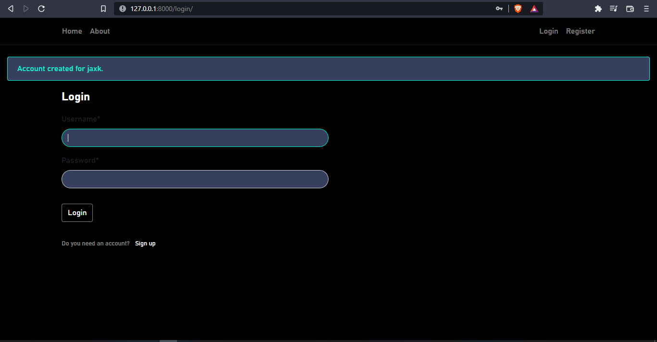

1. Proceed to log in with the just created credentials

Fig 1.4 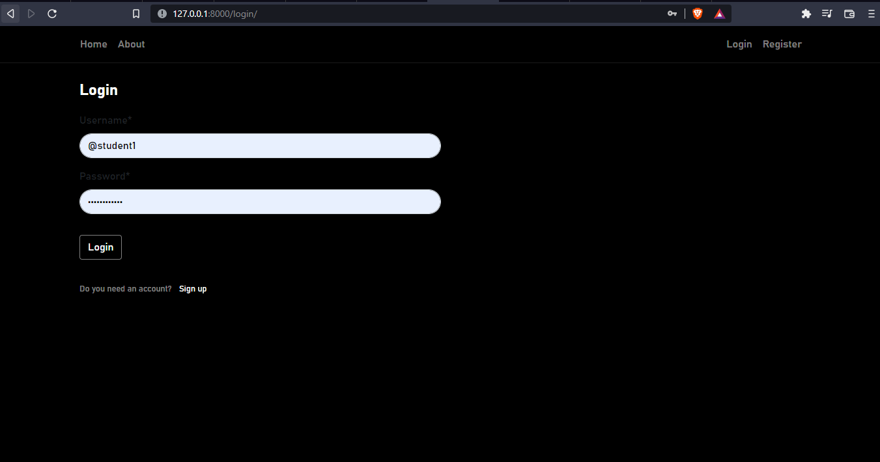

Fig 1.5

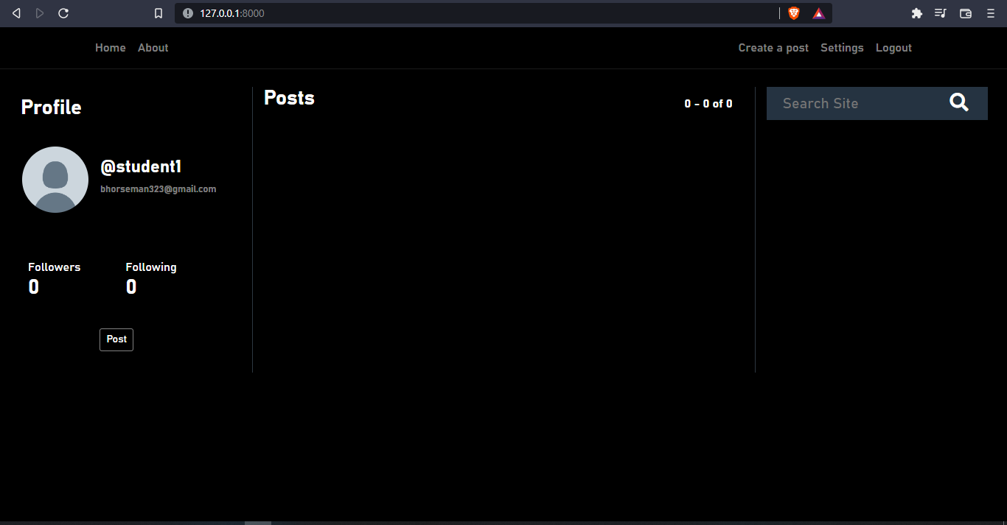

# Login

If you already have an existing account, please follow step 5 as illustrated by figure 1.3 to figure 1.5

# Create a post

## steps

1. Click on post

2.0

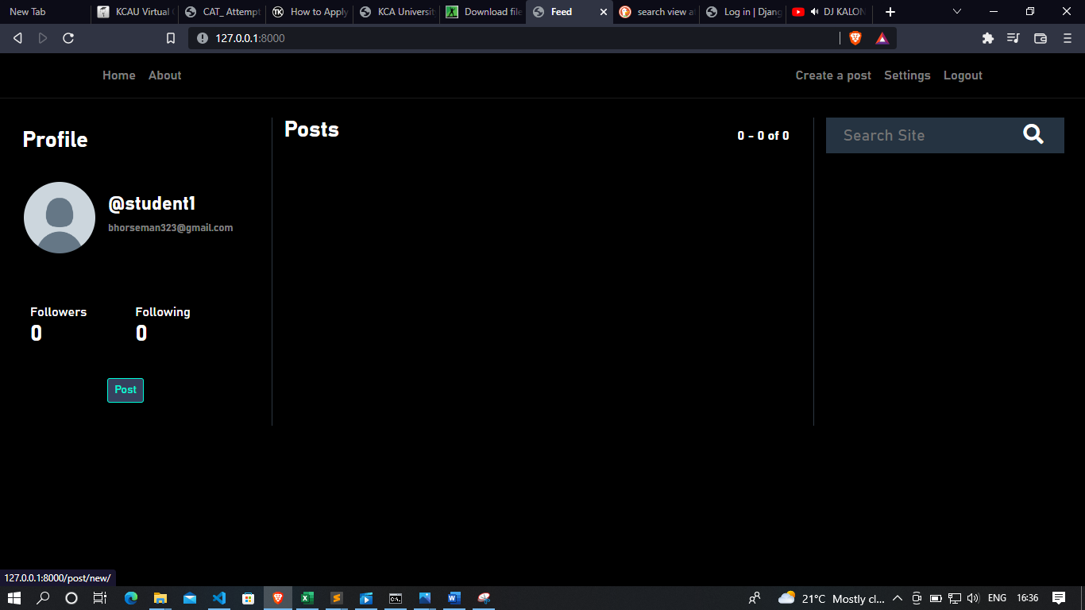

1. This redirects you to a page with a text box labelled Add a new post

Fig 2.1

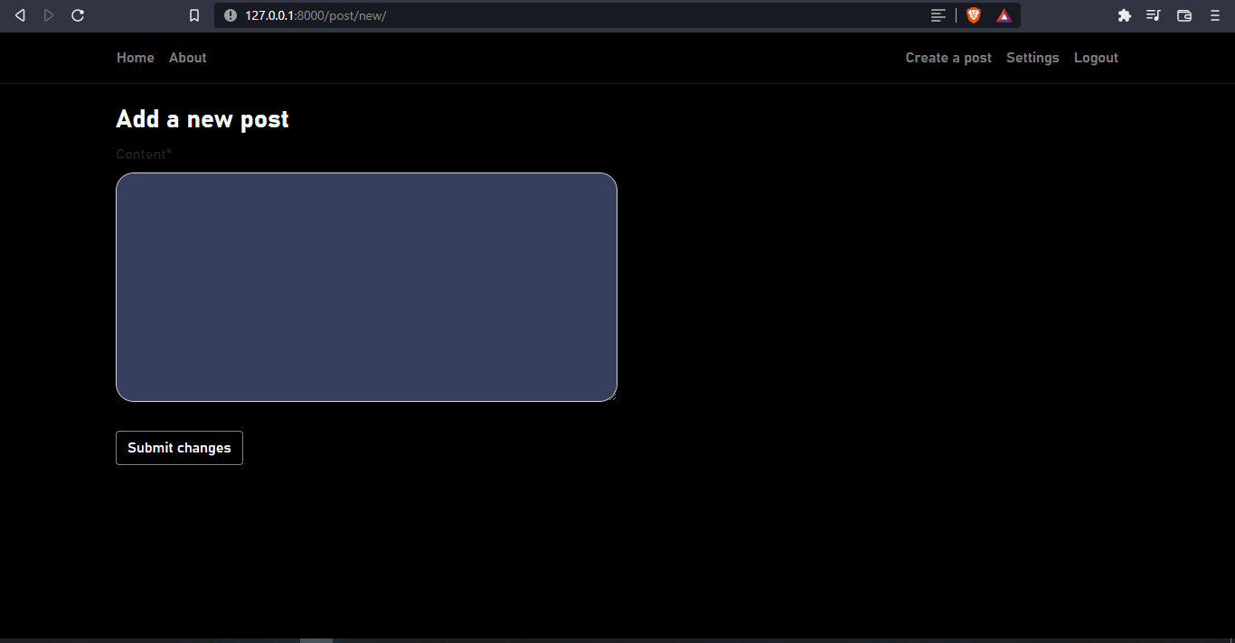

1. Create the new post then click on submit changes to post

Fig 2.2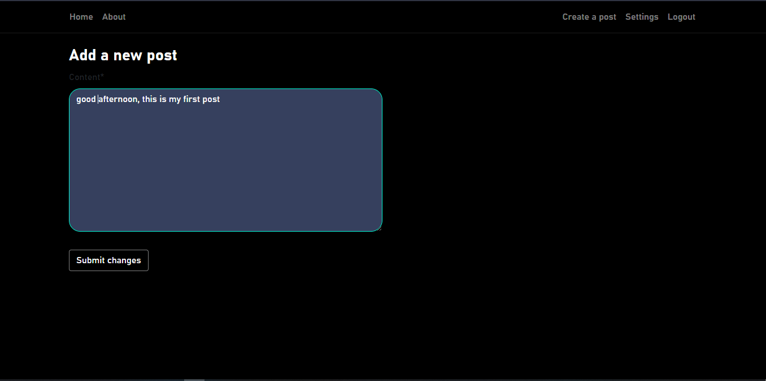

Fig 2.3

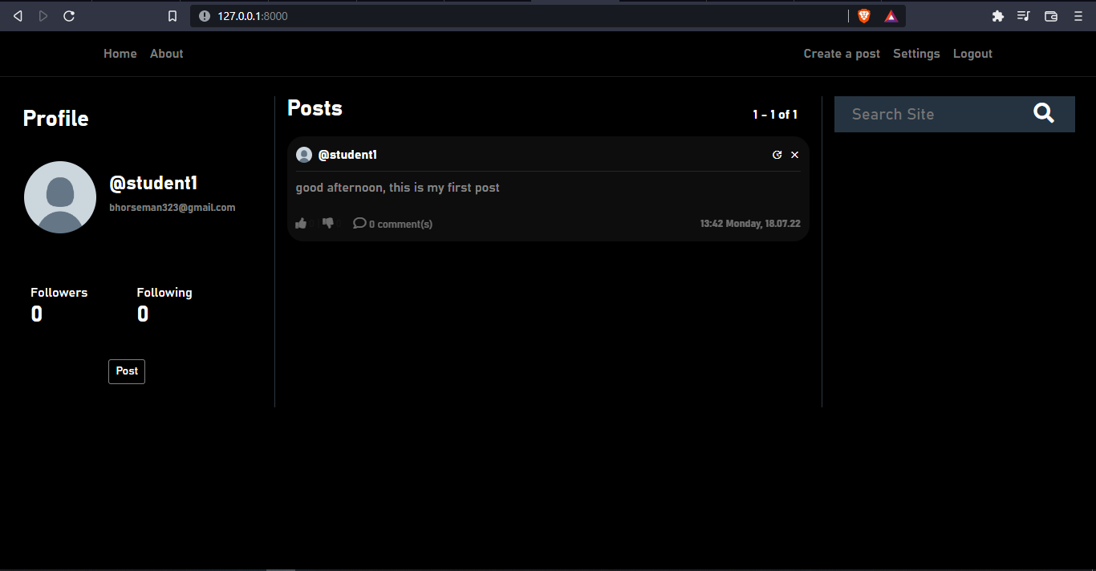

# Editing post

## steps

1. To edit your post, click in the clock icon on the right side of the post
2. You will be redirected to a page with a textbox labelled Edit a post
3. Make necessary changes then click submit changes to effect the changes

Fig 3.0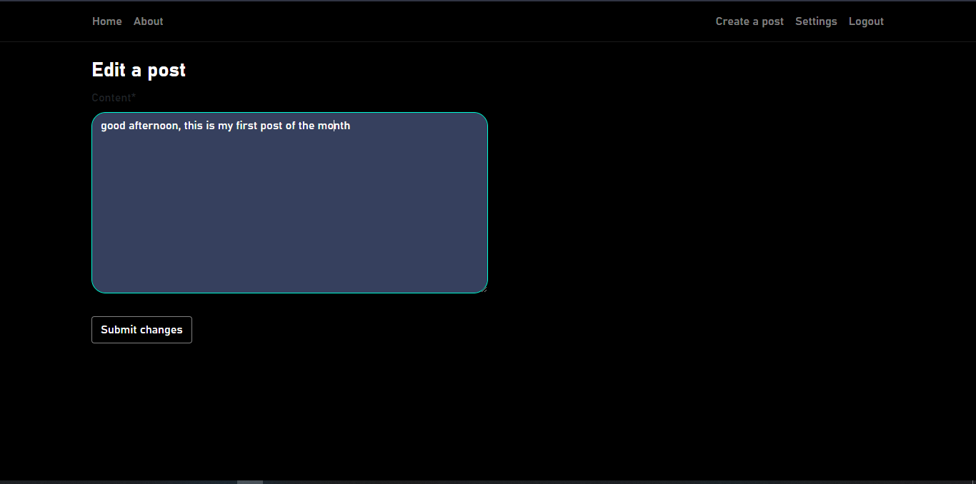

# Deleting post.

## steps

1. Click on the X icon on the right side of the post
2. A confirmation box is displayed to ascertain your decision. Click on yes to delete the post

Fig 4.0

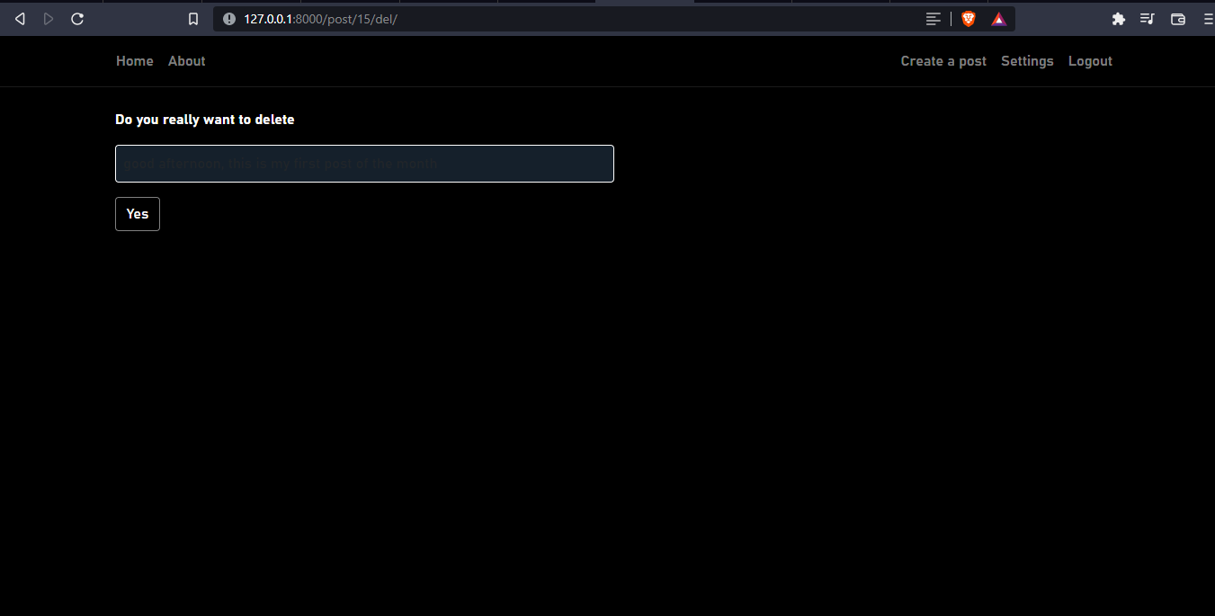

# Commenting on a post

## steps

1. Double click on the post
2. Textbox with Add a comment title appears below
3. Add a comment and click submit

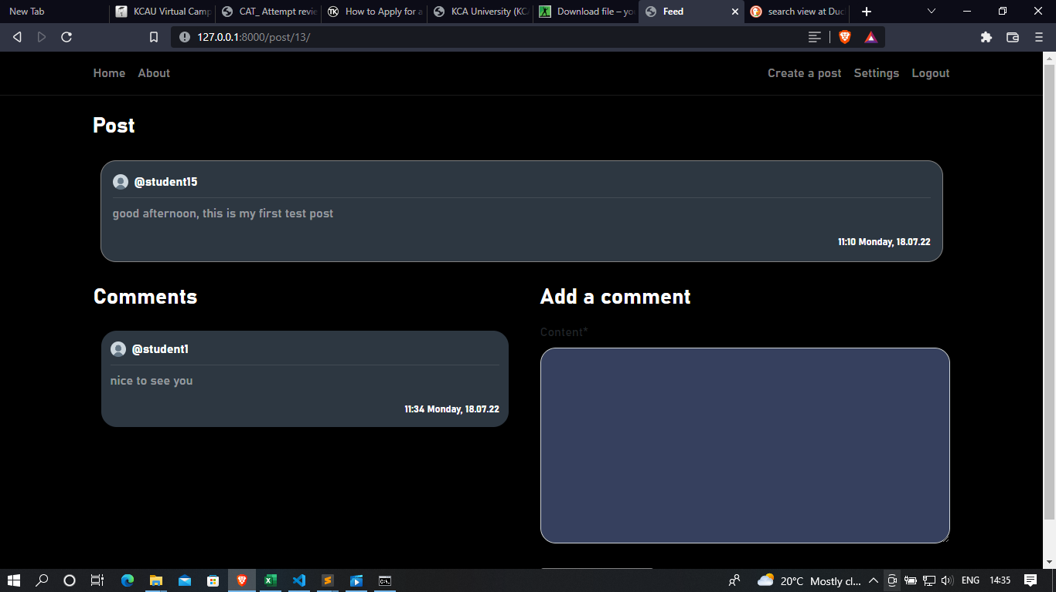

# Seeing your followers

## steps

1. Click on followers

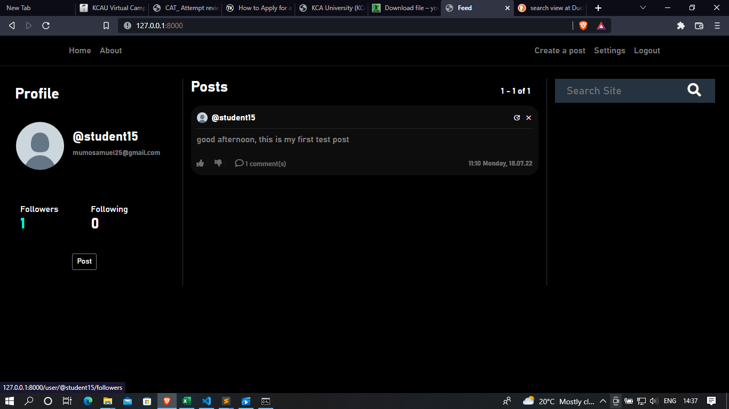

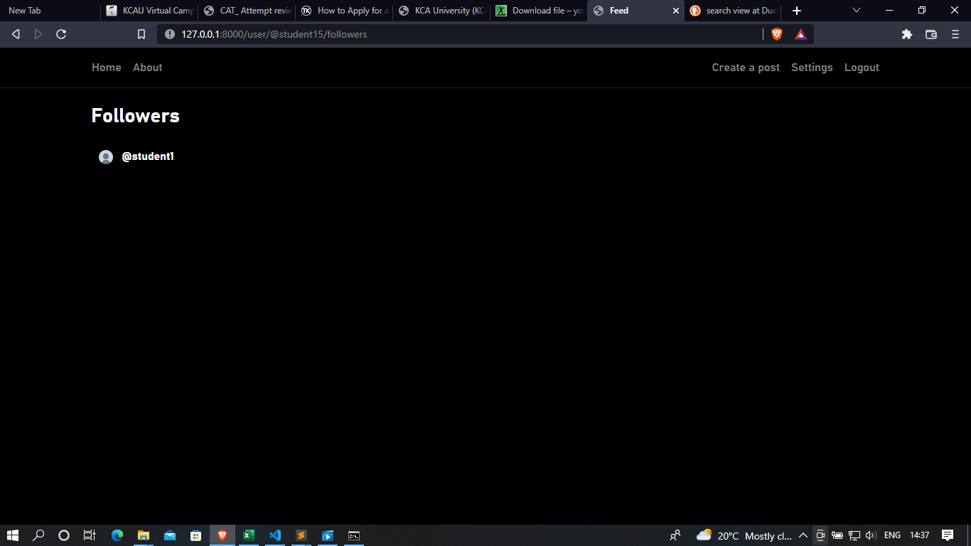

# Using search box

The search box can be used to find other users registered on the platform

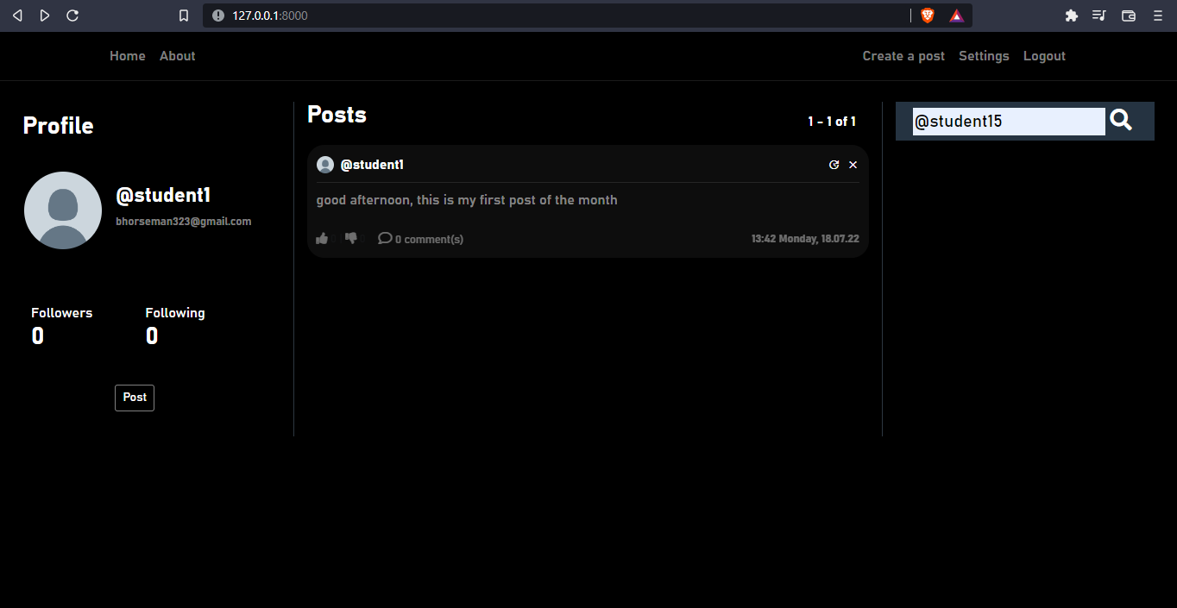

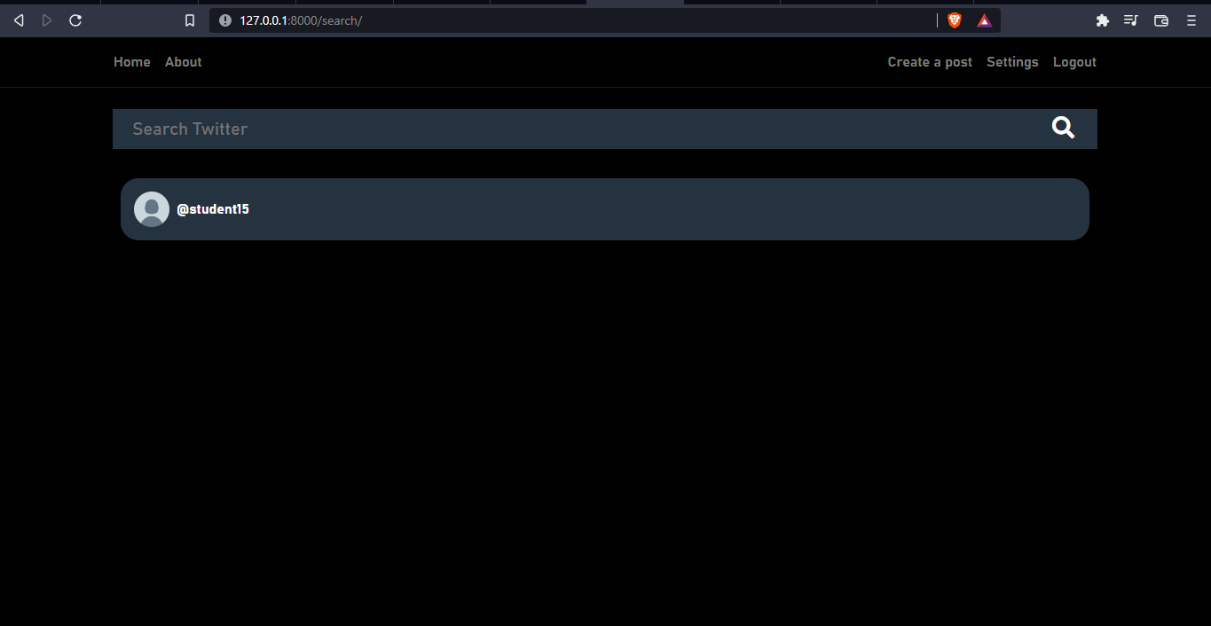

# Following a user

## steps

1. After searching for a user as shown above. Click on the user
2. Click on follow to receive messages they post on your wall

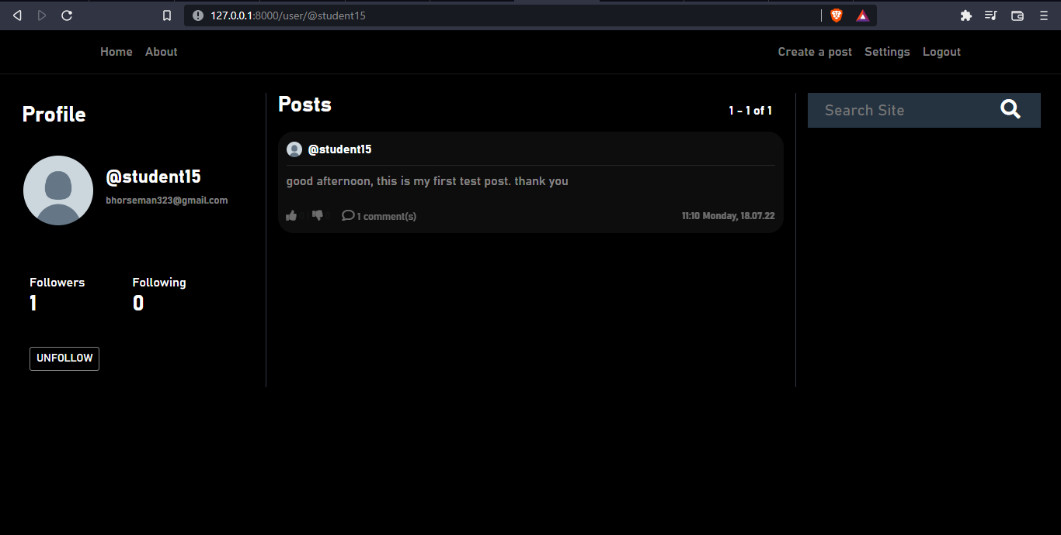

# Unfollowing a user

Click the unfollow button to stop seeing notifications when a user post

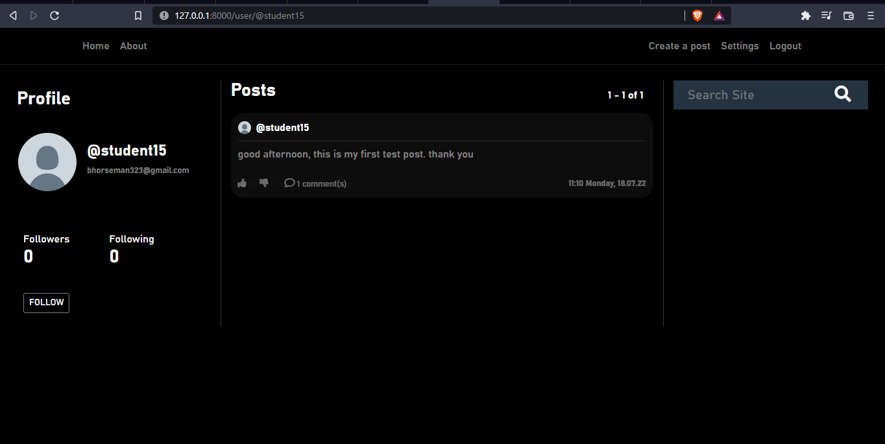

# Liking and dislike

To like a post, click the thumbs up button, similarly to dislike a post click the thumbs down button

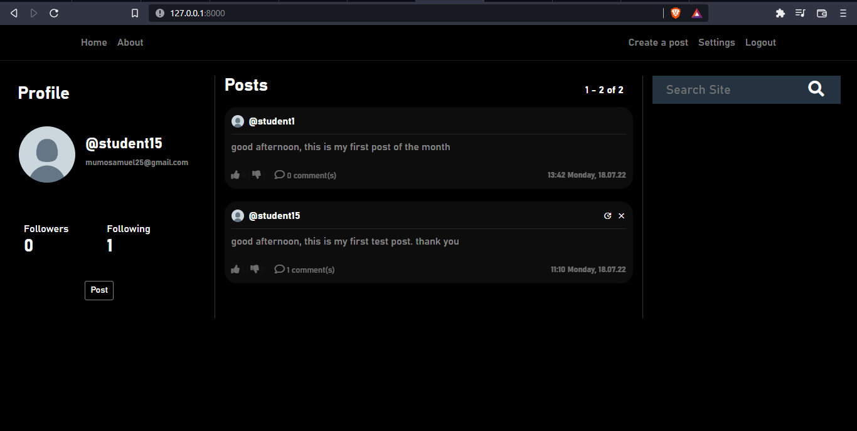

# Change username or email

## steps

1. Click on settings
2. To change your username and username click on the respective fields and make the necessary changes
3. Then click change data to effect the changes

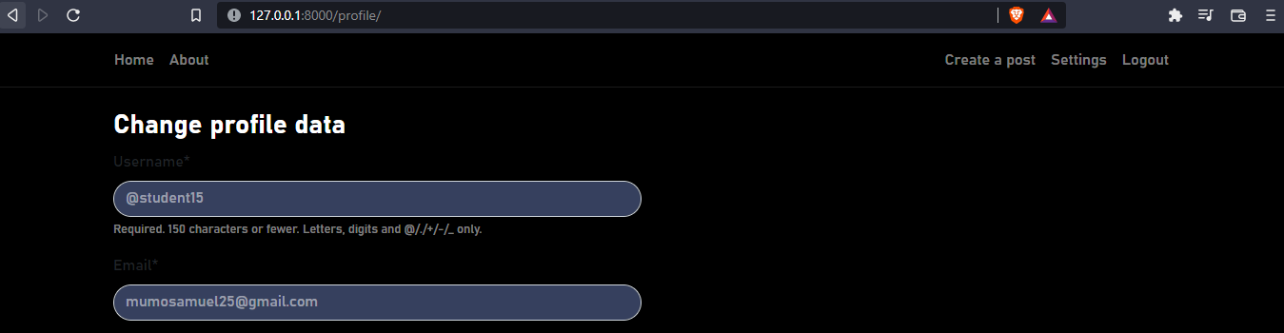

# To change profile picture

## steps

1. Click on settings
2. Navigate to choose image
3. Click on the button and select image from your local database to upload
4. Then click change data to effect the changes

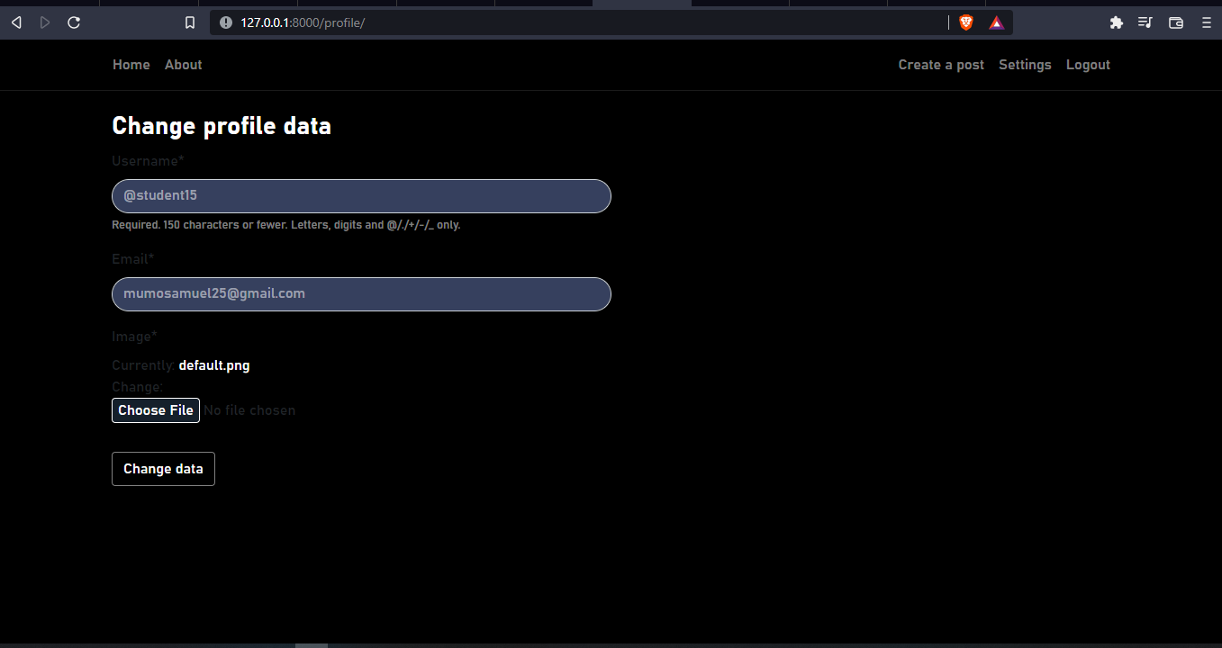

# Creating admin prompt

## steps

1. Proceed to the command prompt
2. type python manage.py createsuperuser then follow prompts to create account

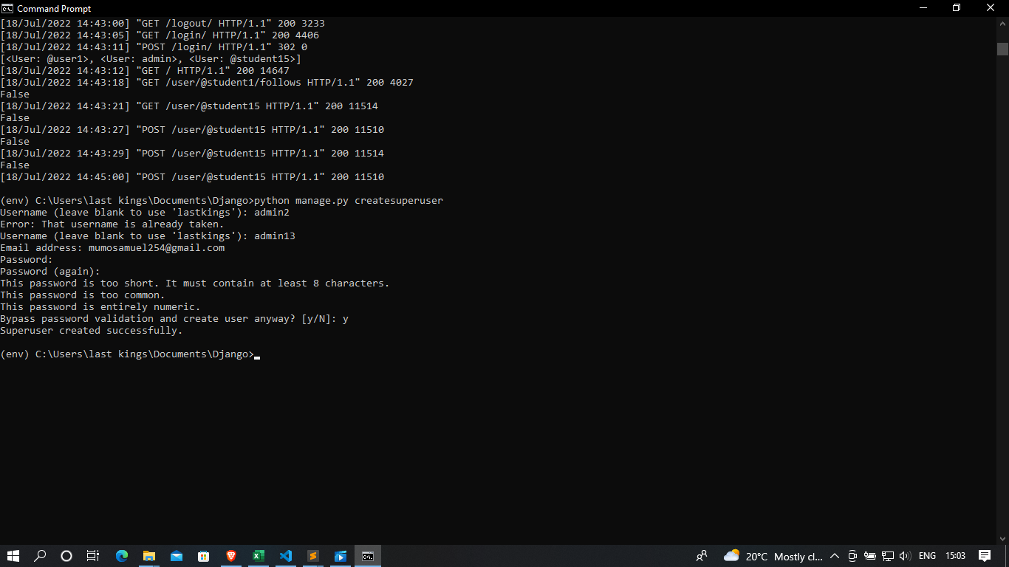

# Login as admin

1. use valid credentials

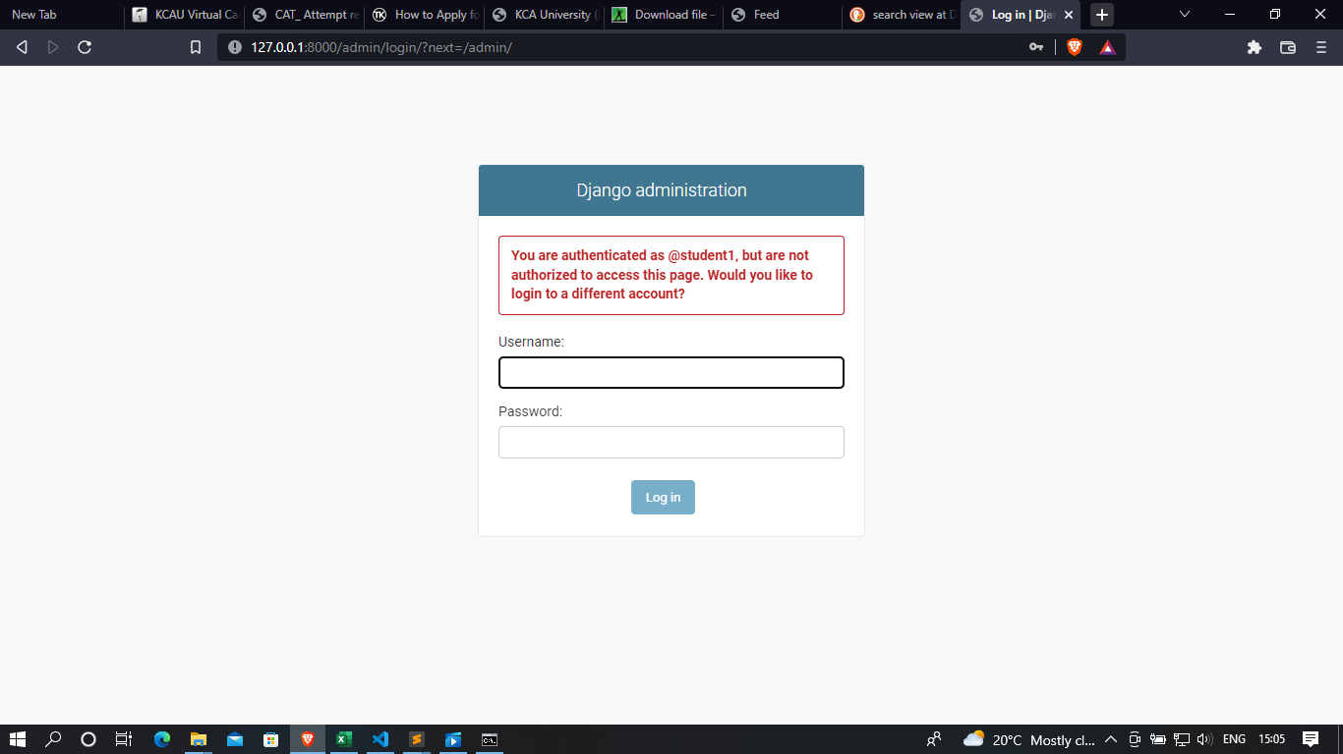

# Create group

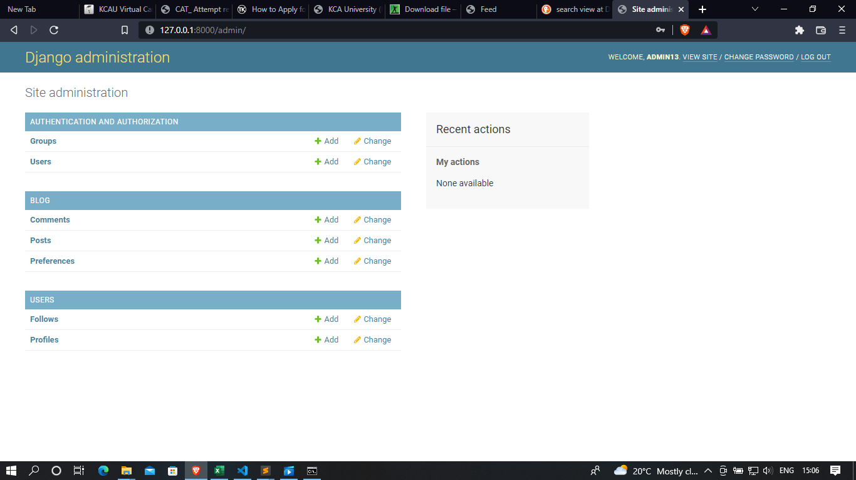

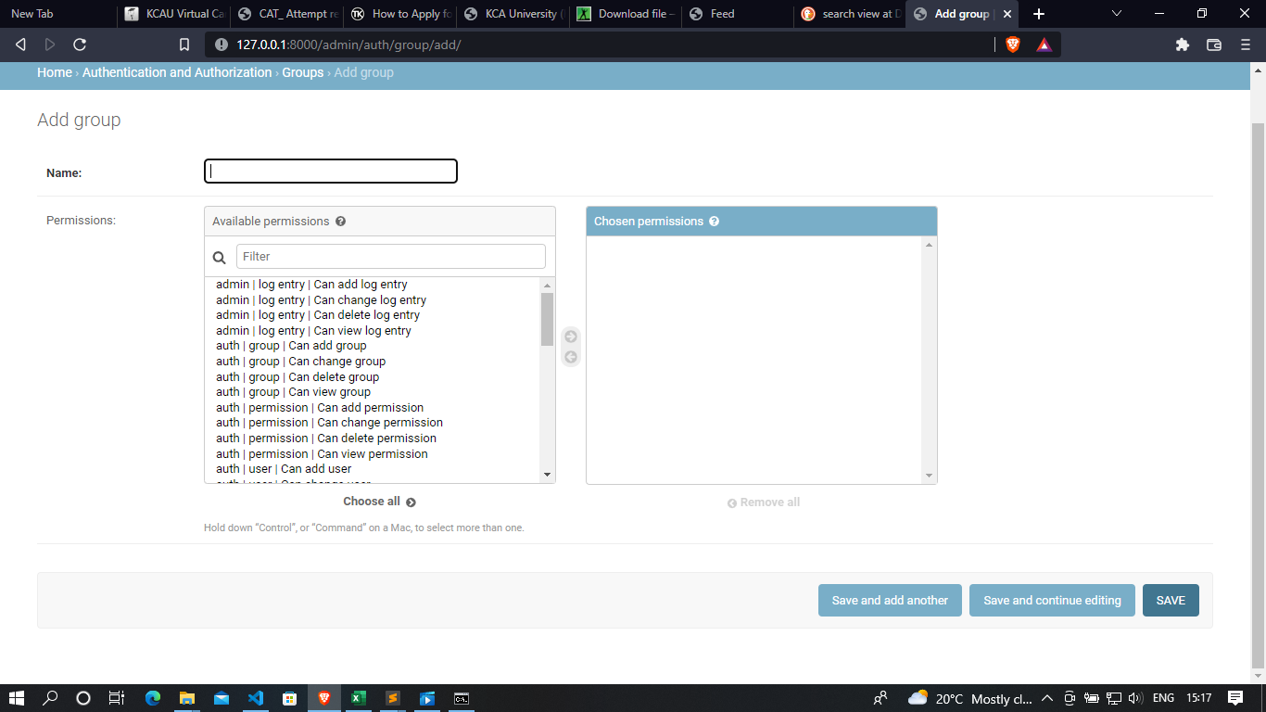

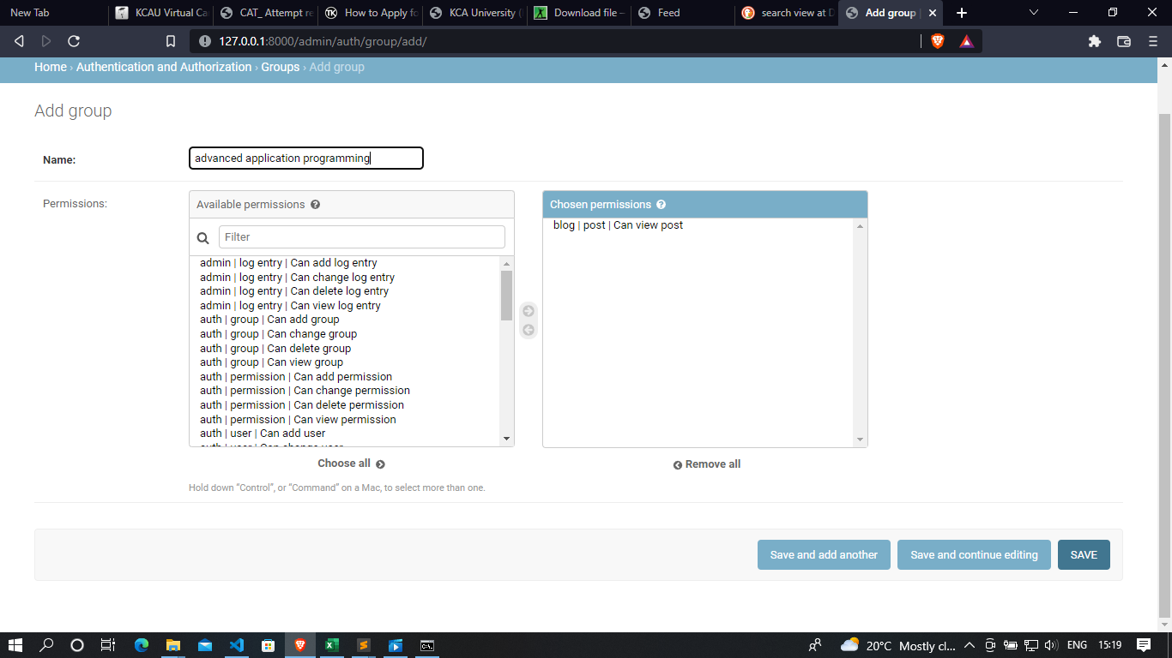

# Adding users to groups

